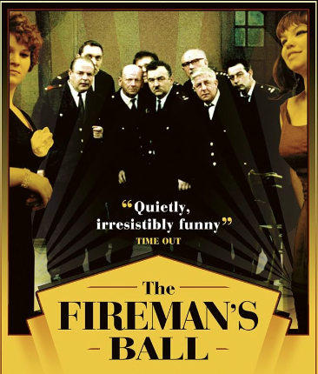

Elam Corporation

Ms. Patsy Richardson

123 Main St.

Winnipeg, Manitoba

R2B 5F2

Dear Ms Richardson

This letter is a confirmation of your request for a ticket to the Annual Fireman’s Ball. Our corporation is happy to provide the ticket to you at **no cost.**

As you will note from the tickets, the Ball is being held **November 25th** at the **Norseman Inn** and will begin promptly at 9 p.m. The famous band, **Cappy’s Capers**, will provide an entertaining evening of dancing and comedy.

Thank you for allowing our company to be of service to you.

Warmest Regards

Elam Tono